**UID LAB EXP 7**

**Login Screen Variations using GIMP**  
**Name:** Saravanan B  
**Reg. No.:** 230701293

**Aim**

To design and compare multiple login screen UI layouts using GIMP, focusing on layout structure, color combinations, readability, and user experience across different themes.

**Tools Used**

* GIMP (GNU Image Manipulation Program)

**Procedure**

**Step 1: Install GIMP**

* Download and install GIMP from the official [GIMP website](https://www.gimp.org/).

**Step 2: Create a New Project**

* Launch GIMP and start a new project with canvas dimensions of 1000x700 pixels (optimized for mobile screen mockups).

**Step 3: Design Multiple Login Screens**

**Login Screen 1 – Light Theme (Left Panel)**

**Elements:**

* Header: “Home” (blue background tab)
* Title: *“Welcome to the App”* (black text)
* Input Field: Email (light gray box)
* Button: *“Login”* (blue, rounded button)

**Design Notes:**

* **Color Scheme:** Clean white background with blue accents
* **Typography:** Clear, black text for high readability
* **Design Aesthetic:** Modern and minimal

**Login Screen 2 – Dark Theme (Middle Panel)**

**Elements:**

* Header: “Home” and “Settings” (black background with white tabs)
* Title: *“Welcome to the App”* (grayish white text)
* Input Field: Email (dark gray input field)
* Button: *“Login”* (teal green rounded button)

**Design Notes:**

* **Color Scheme:** Dark background for night mode appeal
* **Typography:** White and light gray text for good contrast
* **Design Focus:** Suitable for low-light environments

**Login Screen 3 – Warm Theme (Right Panel)**

**Elements:**

* Header: “Home” (purple tab)
* Title: *“Welcome to the App”* (deep maroon text)
* Input Field: Email (light cyan)
* Button: *“Login”* (orange rounded button)

**Design Notes:**

* **Color Scheme:** Soft peach background with vibrant elements
* **Typography:** Stylish, readable contrast
* **User Experience:** Friendly and engaging tone

**Output Screenshot**

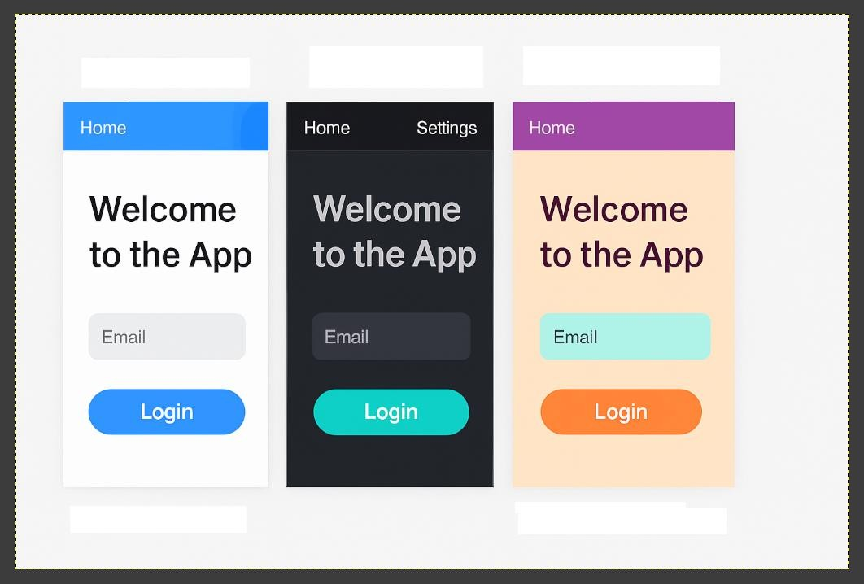

**Conclusion**

The experiment successfully showcases the design of three distinct login screen layouts using GIMP, each tailored for different user preferences and environments. The use of typography, layout symmetry, and varied color schemes illustrates the importance of UI adaptability and visual appeal in app design.